Name: ______________________ Date: ________________
END OF YEAR SOCIAL STUDIES STUDY GUIDE

VOCABULARY
Directions: Write the correct vocabulary word next to its definition.
map map key symbols cardinal directions physical map political map goods service buyer producer seller money location transportation season weather barter democracy citizen rule law service project responsibility conflict history fact peninsula globe right government physical environment

- ______________ the story of our past.
- ______________ - something that can be proven.
- A _______________ shows where places are located.
- A ________________ is a list of shapes and symbols used on a map.
- A map uses _____________, or pictures that stand for real things.
- _________________ directions are north, east, south, west
- _______________ maps show borders of states and countries.
- A ____________ map shows different types of land.
- A _____________ is land with water on all sides except one.
- A ____________ is a round model of earth.
- A ___________ is a place
- The ______________ _______________ is the land and water around us.
- _______________ is the way that people move from place to place.
- ______________ is how hot, cold, wet or dry it is outside.
- Winter, spring, summer and fall are the ______ of the year.
- __________________ - things that are grown or made.
- __________________ - something good done for others.
- __________________ - to give something and get something else in return.
- _____________ - Something we use to buy goods or services.
- _____________ - people who make or grow goods or provide services.
- _____________ - people who sell goods or services.
- _____________ - people who use money to buy goods and services.
- _____________ - a problem between two or more people.
- _____________ - a rule that everyone must follow.
- _____________ - tells us what we can and cannot do.
- _____________ - a person who belongs to a country.
- _____________ - a freedom we have.
- _____________ - a duty we have.
- _____________ - people who run a community, a state, or a country.
- _____________ ____________ - a school or community activity.
- ____________ - a government that is run by its people.

Directions: Answer the following questions
- Who do we remember on 9/11? ______________________________________________
- Who was the President of the United States on September 11, 2001? ______________________________________________
- Who was the Mayor of New York on September 11, 2001? ______________________________________________
- What buildings were destroyed in New York on September 11, 2001? ______________________________________________
- How can artifacts help us understand what life was like long ago? __________________________________________________________________________________________________________________
- Who can teach us about our family’s history? _________________________________________________________
- What can we learn from a timeline? __________________________________________________________________________________________________________________
- Why is history important? __________________________________________________________________________________________________________________
- Name two goods that are grown.
- ______________________ b. _____________________
- Name two service workers.
- ______________________ b. ______________________
- What is the difference between a good and a service?
  - __________________________________________________________________________________________________________
- How do producers and sellers work together?
  - _____________________________________________________
- Name two people with authority.
  - ___________________________
  - ___________________________
- What can people with authority do to help others?
  - __________________________________________________________________________________________________________
- What are two examples of using power without authority?
  - __________________________________________
  - __________________________________________
- Name two ways we can solve conflicts
  - _______________________________________________
  - _______________________________________________
- Name three ways we celebrate or honor our country with the flag.
  - _____________________________________________________
  - _____________________________________________________
  - _____________________________________________________
- What are three nicknames for the United States flag?
  - __________________________________________
  - __________________________________________
  - __________________________________________

Map Skills
Directions: Use the maps to answer the questions that follow.
POSTCARDS FROM OTHER COUNTRIES
Country | = 1 postcard
Egypt
Germany
China
India

- What does the picture graph show?
  - _________________________________________
- How many postcards did Ariana get from Germany?
  - _________________________
- Did Ariana have more postcards from China or from Egypt? How do you know?
  - _______________________________________________________________________________________________________________________________________________________________

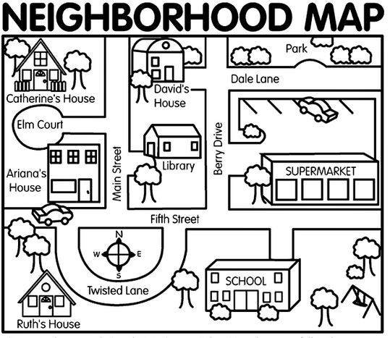
- Draw a compass rose for the map.
- What does the map show?
_____________________________________________________
- On which street does Ruth live?
___________________________
- On which street is the park?
___________________________
- Using cardinal directions. Explain how Catherine gets to school.
____________________________________________________________________________________________________________________________________________________________________________________________________________________________________

